

Tribhuvan University
Faculty of Humanities and Social Sciences

A PROJECT REPORT FOR
“ByteStore
An Intelligent E-Commerce Recommendation System”

Submitted to
Department of Computer Application

Advanced College of Engineering and Management
Kalaki, Kathmandu

In the partial fulfillment of the requirements for
Bachelors in Computer Application

Submitted by:
Abhinav Sapkota (002)
9/26/2026

Under the Supervision of:
Govinda Gautam

Table of Contents

- Abstract iii
- Acknowledgement iv
- List of Figures vii
- List of Tables viii
- Chapter 1: Introduction 9
  - Introduction 9
  - Problem Statement 9
  - Objectives 9
  - Scope and Limitations 9
  - Report Organization 9
- Chapter 2: Background Study and Literature Review 9
  - Background Study 9
  - Literature Review 9
- Chapter 3: System Analysis and Design 9
  - System Analysis 9
  - Process Modeling (DFD) 9
  - System Design 9
  - Interface Design 9
- Chapter 4: Implementation and Testing 9
  - Implementation 9
  - Testing 9
- Chapter 5: : Conclusion and Future Recommendations 9
  - Lesson Learnt / Outcome 9
  - Conclusion 9
  - Future Recommendations 9

List of Figures
Figure 1:Waterfall Model for Bytestore 1
Figure 2:Use Case Diagram for Bytestore 3
Figure 3:Flow chart for Bytestore 4
Figure 4:Gantt Chart for Bytestore 6
Figure 5: ER-Diagram for Bytestore 7
Figure 6:Context Diagram (0 level DFD) for Bytestore 8
Figure 7 :Level 1 DFD for Bytestore 8
Figure 8:Architectural design for Bytestore 9
Figure 9:Database Schema Design of Bytestore 10
Figure 10:Interface design of Admin dashboard of Bytestore 11
Figure 11:Interface design of login page of Bytestore 12
Figure 12:Interface design of cart of Bytestore 12
Figure 13:Home Page demonstration of Bytestore 15
Figure 14:Home Page of Bytestore 23
Figure 15:Customer Login of Bytestore 24
Figure 16: Customer Registration of Bytestore 24
Figure 17:Registered user homepage of Bytestore 25
Figure 18:Checkout Page of Bytestore 25
Figure 19: Staff Login of Bytestore 26
Figure 20:Staff(Employee) dashboard of Bytestore 26
Figure 21:Customer Management of Bytestore 27
Figure 22:Employee Management of Bytestore 27
Figure:23Orders Tab of Bytestore 28
Figure 24:Add New Order of Bytestore 28
Figure 25:Editing Products of Bytestore 29
Figure 26:Management of Employee by Admin of Bytestore 29
List of Tables
Table 1Scheduling Table for Bytestore 6
Table 2:Unit Testing of Bytestore 17
Table 3:System Testing of Bytestore 18

Introduction
Online shopping has grown fast almost everywhere, including in Nepal, where more people now prefer ordering things online instead of visiting a physical store. This project, ByteStore, is a web-based e-commerce platform built for buying technology products such as laptops, smartphones, and accessories. It is built using PHP, MySQL, HTML, CSS, and JavaScript, and it allows customers to register, browse products, add items to a cart, and place orders, while giving admins tools to manage products, customers, and orders from a dashboard.
What makes this version of ByteStore different is that it does not treat every customer the same way. Instead of showing the same product listing to everyone, the platform is being built to actually notice what a customer tends to buy or look at, and use that to recommend things they are more likely to want. This is done using two recommendation techniques, Collaborative Filtering and Content-Based Filtering, both calculated with a method called Cosine Similarity, explained in detail later in this proposal.

.

Problem Statement
Most online shopping today still comes down to a customer searching, filtering by category, and scrolling through a long list of products until they find something they like. As online catalogs keep growing larger, this becomes harder to do, and customers end up spending more time browsing than actually deciding what to buy. This problem is not specific to any one store, it is a general issue with online shopping: platforms have access to a lot of information about what customers do, but a lot of that information is never actually used to help the customer.
This is a real gap. A customer who has bought three gaming laptops in a row is, statistically speaking, probably going to be interested in a gaming mouse or a laptop cooling pad, but a plain e-commerce system with no personalization will show that customer the exact same homepage as someone who has never bought electronics before. The result is a slower, less useful shopping experience than it could be, and stores lose a chance to point customers toward things they would likely buy.

Objectives
The main objective of this project is to design and develop “ByteStore”, a fully functional web-based e-commerce application dedicated to technology products, that provides an efficient digital platform for customers and administrators.
- To design and build a recommendation feature that suggests products to customers based on their own purchase history and the purchase history of similar customers, using Collaborative Filtering.
- To design and build a second recommendation approach that suggests products based on product attributes such as category, brand, and price, using Content-Based Filtering, so that even customers with little or no purchase history still get useful suggestions.

Methodology
This project follows the Evolutionary / Incremental Development model. Under this model, a basic working version is built first, and then improved in stages, with room to revisit and adjust earlier parts as needed. This fits a solo project well, since it does not require locking down every requirement upfront the way a strict Waterfall approach would.

Requirement Identification

Study of Existing System
Before deciding on an approach, it helps to look at how other e-commerce systems are actually built, especially ones that are openly available to study.

One example is a plain PHP and MySQL e-commerce project available on GitHub, built with no external frameworks, offering user registration, a shopping cart, order management, and an admin panel. It covers all the basic CRUD operations expected of an online store, but every customer sees the exact same product listing regardless of what they have bought before. There is no part of the system that adjusts based on customer behavior.

A second example is another full-stack PHP e-commerce platform, also on GitHub, which adds a more advanced admin dashboard with sales analytics and AJAX-based cart handling. Even with these extra features, it still has no way of tailoring what a customer sees. Both systems are solid examples of functional online stores, but they represent the same basic limitation: they collect a lot of customer data through orders and browsing, and use almost none of it to shape the customer's experience.

ByteStore, the platform this project is built around, currently works in a similar way. It is a fully working PHP and MySQL store with the same core functionality as the examples above. This project adds a recommendation layer to it, so it moves past the same limitation these other systems share.

Literature Review
A fair amount of research and real-world work already exists around recommendation systems in e-commerce, and reviewing it helps justify why Collaborative Filtering and Content-Based Filtering were chosen for this project instead of just relying on plain search and filters.

"PLING: Adaptive Opportunity Checking of Web Service with Recommendation System" — published in the International Journal of Pure and Applied Mathematics (2018), this paper presents a hybrid filtering approach combining collaborative and content-based filtering, using cosine similarity to analyze user browsing history and content similarity. It argues that combining both methods handles the growing complexity of information filtering better than using just one. This closely matches the direction of this project.

Item-to-Item Collaborative Filtering study (Iraqi Journal of Science) — this paper describes how item-to-item collaborative filtering, using cosine similarity, is used by Amazon to power its "customers who bought this also bought" feature, without requiring any personal information from the customer beyond their purchase history. It is one of the clearer real-world explanations of why this technique is popular for online stores specifically.

"A Hybrid Collaborative Filtering Method for Multiple-Interests and Multiple-Content Recommendation in E-Commerce" — published in Expert Systems with Applications (2005) by Yu Li, Liu Lu, and Li Xuefeng, this is an older but still frequently cited paper describing how combining collaborative filtering with content information improves recommendation quality in online shopping settings.

"A Personalized Collaborative Recommendation Algorithm Based on Hybrid Information" — presented at the International Conference on Mechatronics, Materials, Chemistry and Computer Engineering (2015) by Dejia Zhang, this paper points out a real weakness in plain collaborative filtering: as the number of customers and products grows, finding the "nearest neighbor" customers becomes slow and less reliable. It proposes combining user and item information together to keep recommendations fast and accurate even as a store's catalog grows, which is a relevant consideration even at ByteStore's smaller scale.

Hybrid recommendation study with Amazon Electronics and MovieLens datasets (2025) — this more recent paper builds a hybrid model combining collaborative filtering, matrix factorization, and a content-based fallback for new customers, tested on real Amazon Electronics purchase data. It notes that recommended products already make up a significant share of Amazon's overall revenue, which is a useful, concrete number showing why stores keep investing in this feature instead of treating it as optional polish.

Brazilian E-Commerce Public Dataset by Olist (Kaggle) — a widely used dataset containing real sales data from about 100,000 orders, including customer behavior and order items. It has been used in many public notebooks to study buying patterns and build recommendation models, and is a good reference point for how order and product data, similar to what ByteStore already stores, can be turned into recommendations.

E-Commerce Purchase History Dataset, Electronics Store (Kaggle) — this dataset is particularly relevant since it focuses specifically on an electronics store, which lines up closely with ByteStore's own catalog. It has been used in student and independent projects to build and compare collaborative filtering and content-based filtering models on real purchase behavior.

"Building and Optimizing a Personalized Recommendation System for E-Commerce Using Machine Learning" (independent MSc dissertation project, published on GitHub) — this project is worth mentioning because it is close in spirit to this one: a student-built e-commerce prototype using PHP, MySQL, and XAMPP, paired with collaborative filtering, content-based filtering, and a hybrid model. Its写 results show that collaborative filtering performed noticeably better than content-based filtering alone in terms of accuracy, but content-based filtering still held up better for newer users, which supports the decision to use both together rather than picking one.

"A Content-Based Recommender for E-Commerce Web Store" — a published data science project write-up that builds a content-based recommender for an online store using product category and price information. It lays out the trade-off clearly: content-based filtering avoids the cold-start problem but depends entirely on having good product attribute data, while collaborative filtering can find surprising, less obvious recommendations but needs a decent amount of purchase history to work well. This trade-off is the main reason this project is not relying on just one of the two methods.

Taken together, these sources support the same idea from a few different directions: relying on plain search and category browsing leaves a lot of useful customer data unused, collaborative filtering and content-based filtering solve different halves of the same problem, and using both together, tied by cosine similarity, is a well-established and realistic approach rather than something overengineered for a project of this scope..

Requirement Analysis

Functional Requirements:
- Can add, edit, delete and view all users
- The system should build a record of which products each customer has purchased.
- The system should build a profile for each product based on attributes such as category, brand, and price range.
- The system should calculate similarity scores using cosine similarity, comparing customers to each other for collaborative filtering, and comparing products to each other for content-based filtering.
- The system should generate a combined, ranked list of recommended products for each customer.
- The admin should be able to see which products are being recommended most often through the dashboard.

Non-Functional Requirements:
- Recommendations should load quickly enough that they do not noticeably slow down the site.
- The recommendation module should be built using Object-Oriented Programming, so it stays organized and easy to extend later.

Use case diagram
The system involves two actors: Customer and Admin. The customer sees recommended products while browsing or after checkout, while the admin can view recommendation activity through the dashboard.
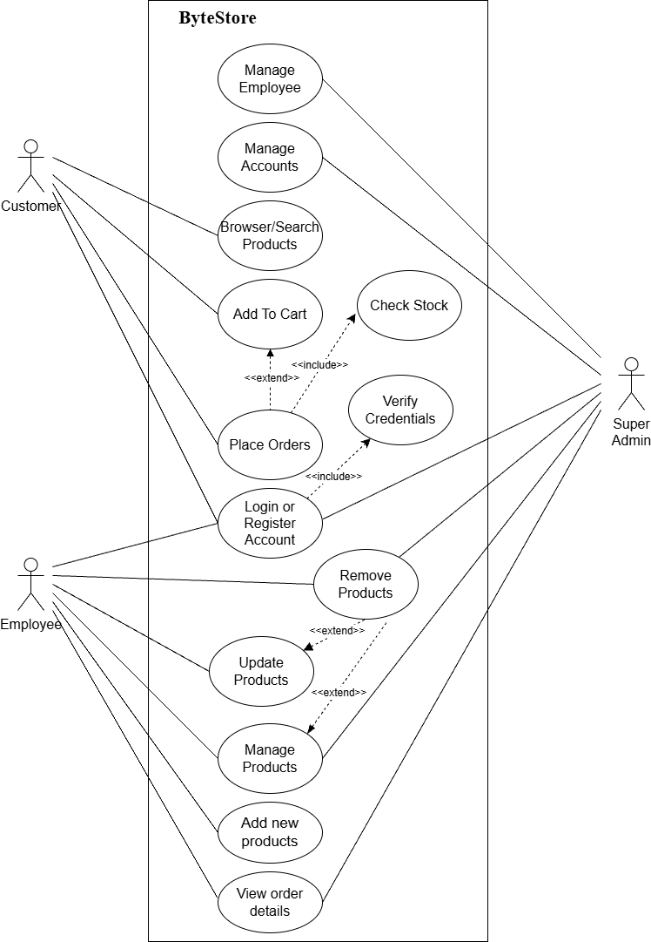

Figure 2:Use Case Diagram for Bytestore

Flow chart
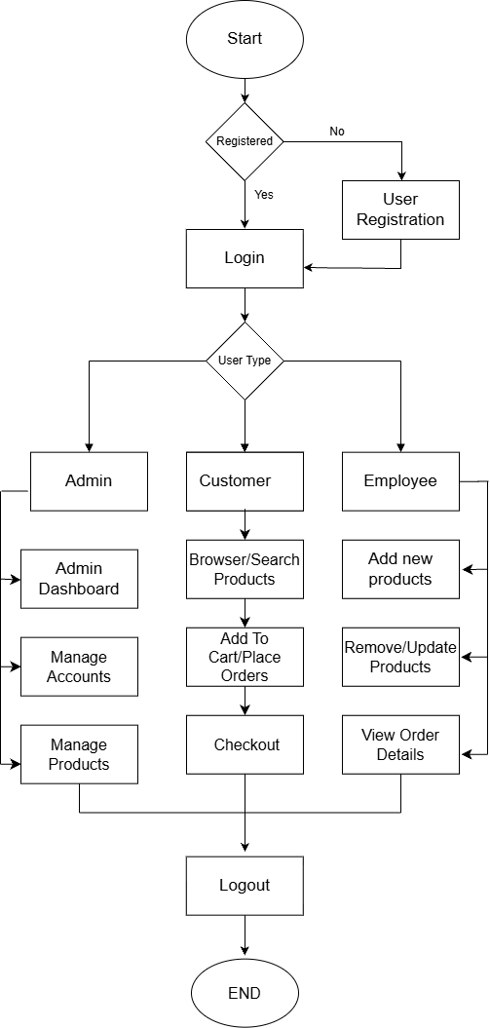

Figure 3:Flow chart for Bytestore

Non-Functional Requirements:
Security
This system has accounts for its users and only authorized users can access the system with username and password. The passwords are encrypted using a PHP function PASSWORD_DEFAULT.
Availability
This system is available to users anytime, anywhere, just need a PC or Mobile and Internet Connection. Also, the system works in multiple web browsers like (Chrome, Mozilla and Opera).
Reliability
The system must be 100% reliable due to the importance of data and the damage that can be caused by incorrect or incomplete data. The system will run 7 days a week, 24 hours a day.
Maintainability
The system will be easily maintained by the developer or other authorized trained person and Backup for database can be done easily.

Feasibility Analysis
Feasibility study checks whether the project is practical, cost-effective, and achievable.
- Technical Feasibility:
The system uses PHP, MySQL, HTML, CSS, and JavaScript, which are freely available and supported by XAMPP. Tools are easy to learn, making implementation technically possible.
- Economic Feasibility:
Since it is an academic project, costs are minimal (local hosting, no domain/hosting required yet). Development requires only time and effort, so it is economically viable.
- Operational Feasibility:
The system will be simple for users to browse and order products, and for employees to manage product listings. It meets both user needs and project objectives, making it operationally feasible.
- Schedule Feasibility
This assessment is the most important for project success; after all, a project will fail if not completed on time. In scheduling feasibility, an organization estimates how much time the project will take to complete. To calculate and continually reexamine whether it is possible to complete all amount and scope of work lying ahead, utilizing the given number of resources, within required period. In my project
I used Gantt Chart for Schedule feasibility study. To calculate and continually reexamine whether it is possible to complete all amount and scope of work lying ahead, utilizing the given number of resources, within required period. In my project we used Gantt Chart for Schedule feasibility study.
Gantt Chart
Gantt chart is a bar chart that provides a visual view of tasks scheduled over time. A Gantt chart is used for planning projects of all sizes, and it is a useful way of showing what work is scheduled to be done on a specific day. It can also help you view the start and end dates of a project in one simple chart. In my project, we used Ms. Excel for developing the Gantt chart which is shown below in the figure.

Table 1Scheduling Table for Bytestore
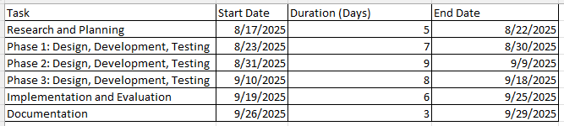

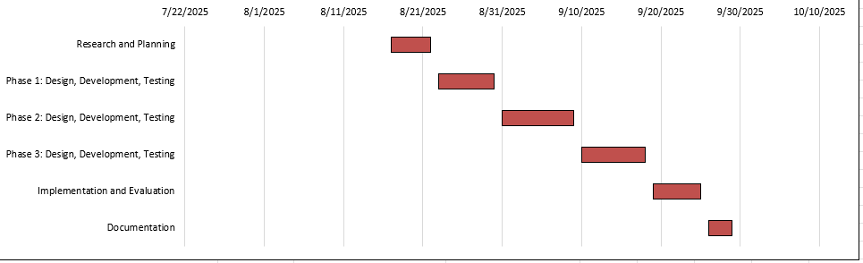

Figure 4:Gantt Chart for Bytestore

Data Modelling (ER-Diagram)
This ER (Entity Relationship) diagram represents the model of this project (Bytestore). The entity-relationship diagram of project shows all the visual instruments of database table and the relations between customer, products, employee and admin etc. It used structure data to define the relationship between structured data groups of Bytestore). functionalities. The main entities of this project are customer, products, employee and admin.
ER Diagram
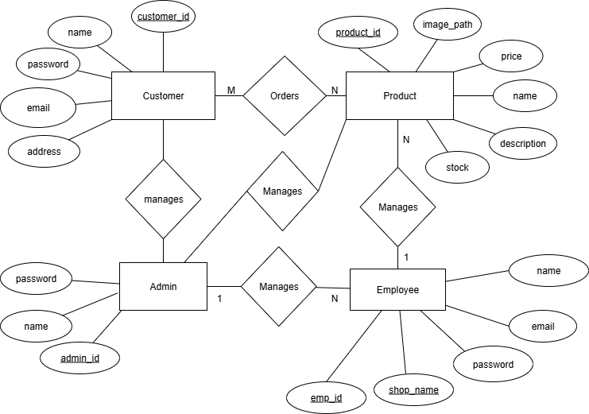
1
M,

Figure 5: ER-Diagram for Bytestore
In the above er-diagram there are four entities as customer, products, employee and admin, each entity has its own attribute and primary key.
The figure simply shows entity customers can order products and products have their own id and description. This figure shows that many customers have orders, one admin can manage many employes and one employee can manage many products.

Process Modeling (DFD)
Data Flow Diagrams show the flow of data from external entities into the system, and from one process to another within the system. Following are the Data Flow Diagrams for the current system. Each process within the system is first shown as a Context Level DFD and later as a Detailed DFD. The Context Level DFD provides a conceptual view of the process and its surrounding input, output and data stores. The Detailed DFD provides a more detailed and comprehensive view of the interaction among the subprocesses within the system. Which is explain below in figure

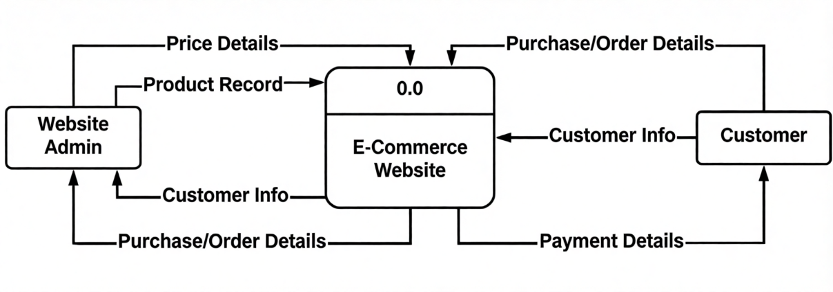

Figure 6:Context Diagram (0 level DFD) for Bytestore
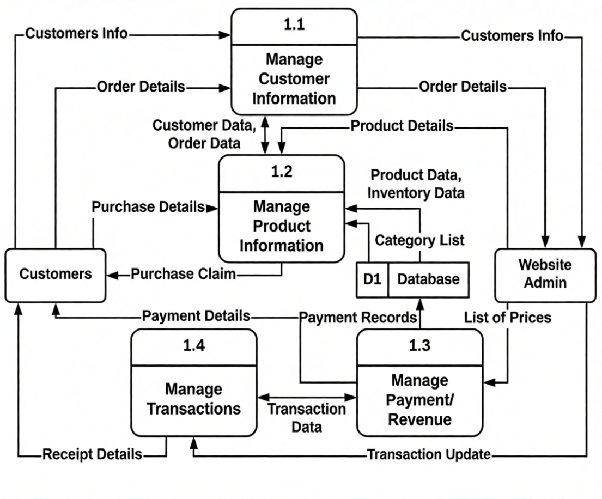

Figure 7 :Level 1 DFD for Bytestore

System Design

Architectural Design
The next phase of design will be planning the architecture of the application. There will be in some cases a separation of the user interface and data. The business layer will be totally independent and not embedded in the views of the website. Data will be stored in an SQL database. To query the database and code behind for server-side scripting will be in PHP. The other business objects will have their own layer. The architecture of the application is shown below in figure:
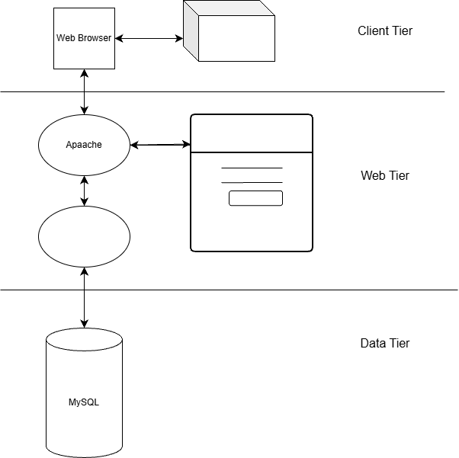
PHP

Figure 8:Architectural design for Bytestore

Database Schema Design

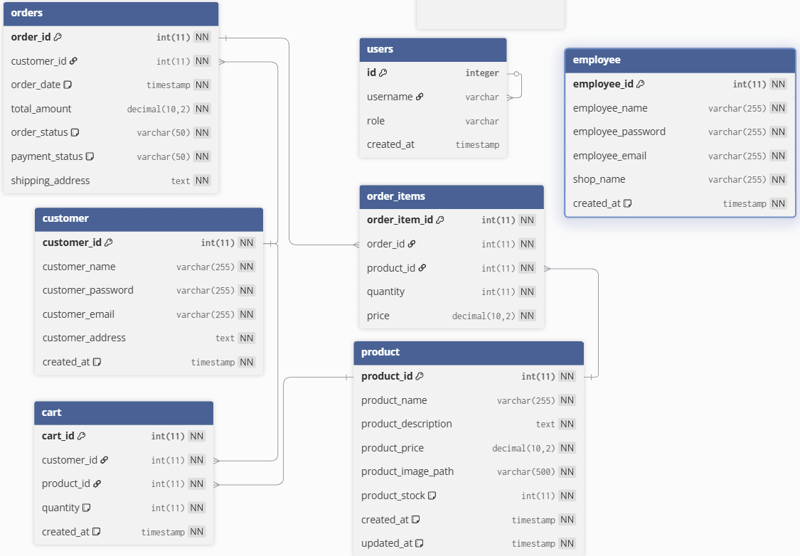

Figure 9:Database Schema Design of Bytestore
The design of the database is called a schema. This tells us about the structural view of the database. It gives us an overall description of the database. A database schema defines how the data is organized using the schema diagram.
In the above database schema design, we have tables Customer, Employee, Product, cart, order_items and User. So, we can represent the schema of these tables using the schema diagram as above. In this schema diagram Customer, Product, Cart, order_items are related

Interface Design
Before implementing the actual design of the project, a few user interface designs were constructed to visualize the user interaction with the system as they browse for books, search, registration, login and purchase books. The user interface design will closely follow my Functional Decomposition Diagram show the initial designs of the web pages using Figma.
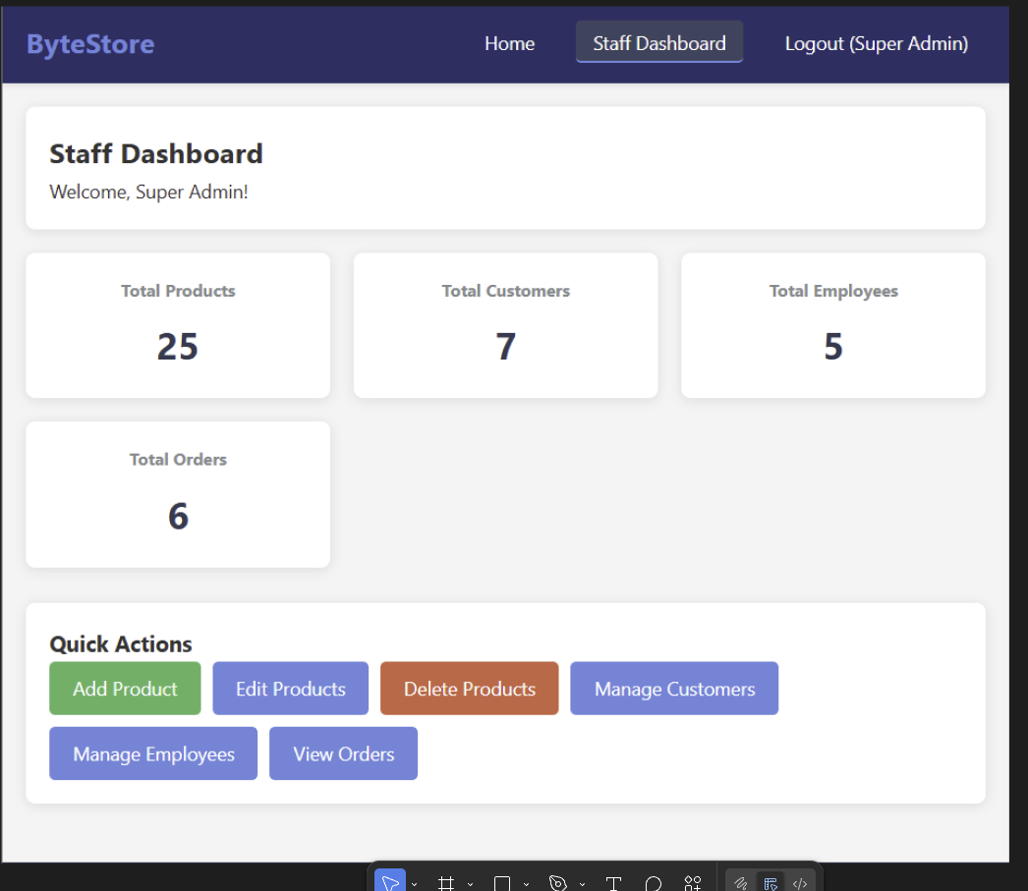

Figure 10:Interface design of Admin dashboard of Bytestore

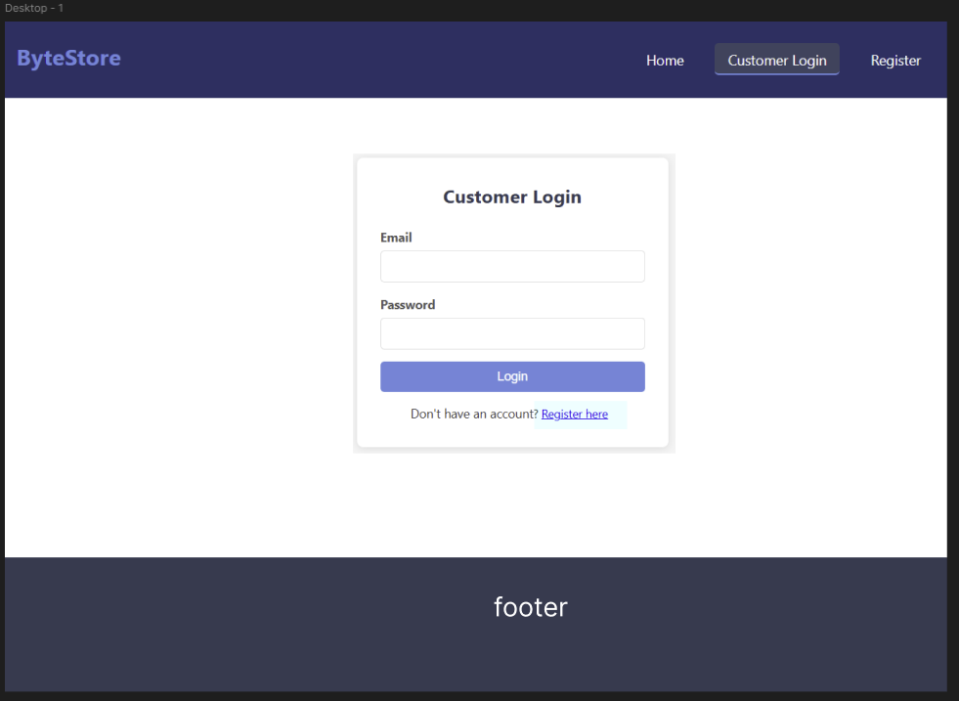

Figure 11:Interface design of login page of Bytestore

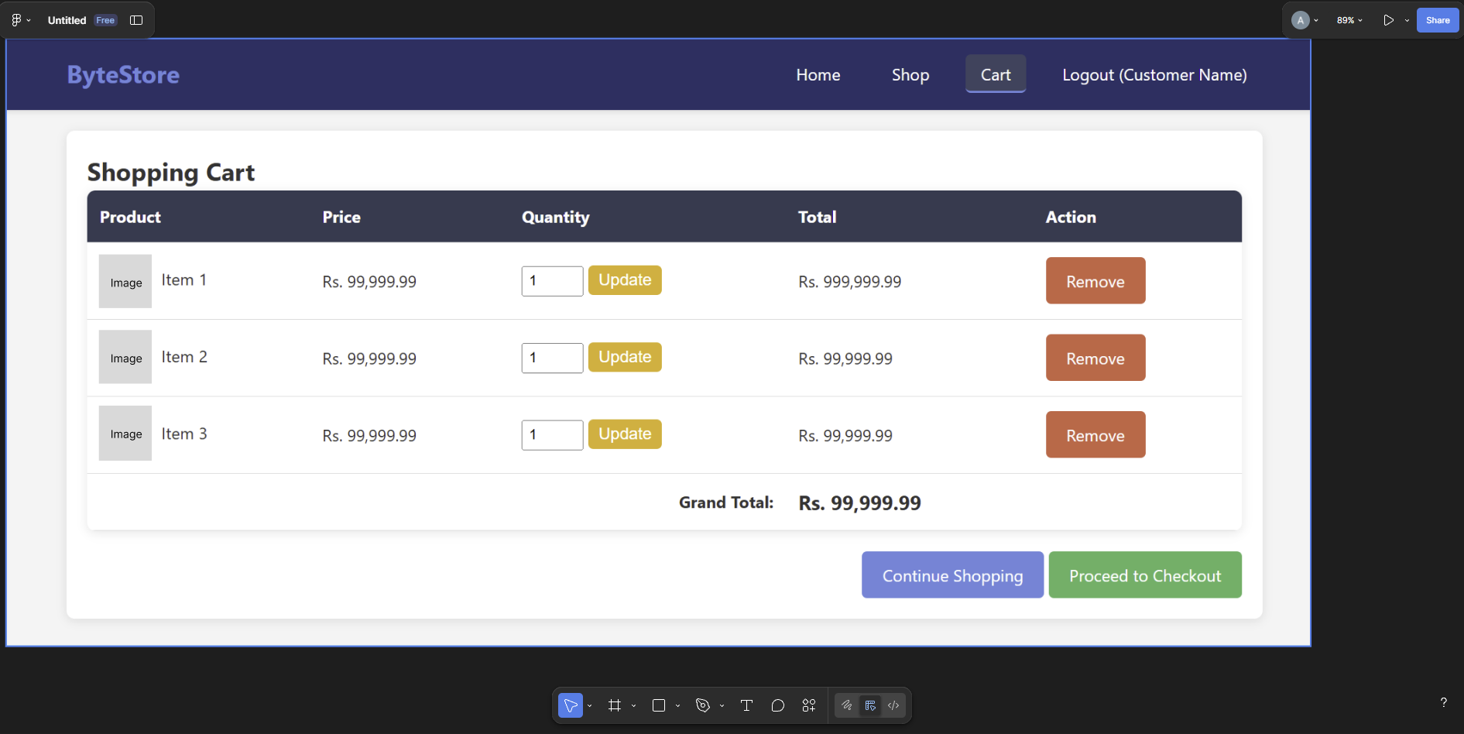

Figure 12:Interface design of cart of Bytestore

    - Physical DFD
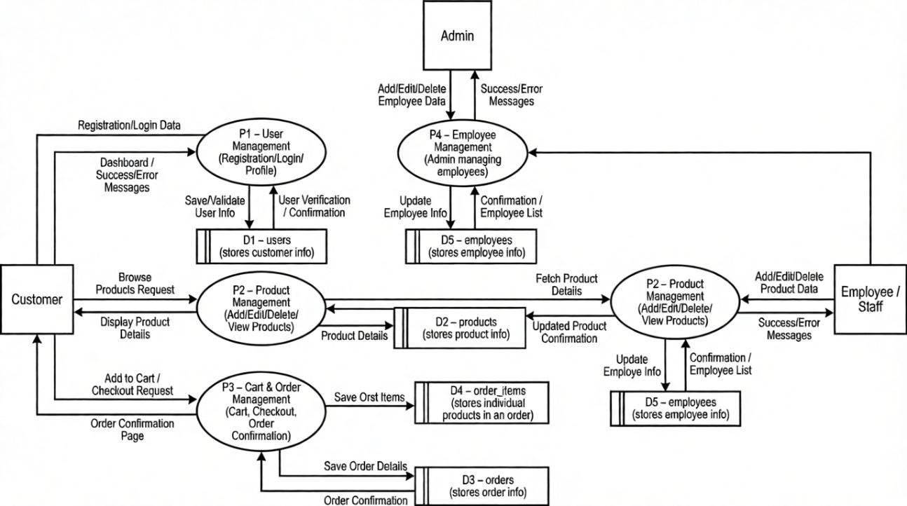

Figure 21: Physical DFD of Bytestore
Physical data flow diagram shows how the data flow is implemented in the system. Physical DFD is more specific and closer to implementation. Figure illustrated above shows a physical DFD of. Bytestore.

Implementation and Testing

Implementation

Tools Used -The various system tools that have been used in developing both the frontend and the backend of the project are being discussed in this chapter.

Frontend
Figma, HTML, CSS, JavaScript, and PHP are utilized to implement the frontend.
Figma (Starter)
Figma is used to design over all layouts of the project.
HTML5 (Hyper Text Markup Language)
HTML5 is a syntax used to format a text document on the web. It is used to create overall structure of the project.
CSS3 (Cascading Style Sheets)
CSS3 is a style sheet language used for describing the look and formatting of a document written in a markup language. It is used to give the looks to the project.
Java Script V8 8.9.255.25
Java Script is a dynamic computer programming language. It is mostly used as part of web browsers, whose implementations allow client-side scripts to interact with the user, control the browser, communicate asynchronously, and alter the document content that is displayed. Java Script is used to create popup windows displaying different alerts in the system like "Are you sure you want to delete this user?"," search functionality" etc.
PHP 7.4.11
PHP is a server-side scripting language designed for web development but also used as a general-purpose programming language. It is used to dynamically display pages in the project and interact with database.

Backend
The back end is implemented using MySQL which is used to design the databases.
MySQL 8.0.22
MySQL is the world's second most widely used open-source relational database management system (RDBMS). The SQL phrase stands for Structured Query Language. MySQL is used to store all the data of project.
Other Tools used Git and GitHub Git and GitHub are used for version control and as a code repository. I also used GitHub project features to track the project.

Modules Implementation
After the design was made and the problems arising from the design process were clarified and dealt with, it was time to start implementing the application. Implementing application of this scale requires lots of resources and explaining the whole implantation process will not be clarified in this paper. However, major important aspects in the implementation will be described.
Figma is used to design over all layouts of the project. and every other implementation like HTML and CSS tagging was done using Visual Studio. There is only one style sheet for whole website. The CSS style sheets are all linked to the master pages hence there is less presence of inline styling. The actual implementation has been done using PHP. PHP has been used to interact with the backend database. In this implementation, My SQL Server has been used as the backend RDBMS. PHP processes the inputs or commands given by the user and translates them into commands understandable to the backend database. The output produced by the backend database is also handled by PHP which is then displayed on the browser screen. After the design here is how the final home page looked like
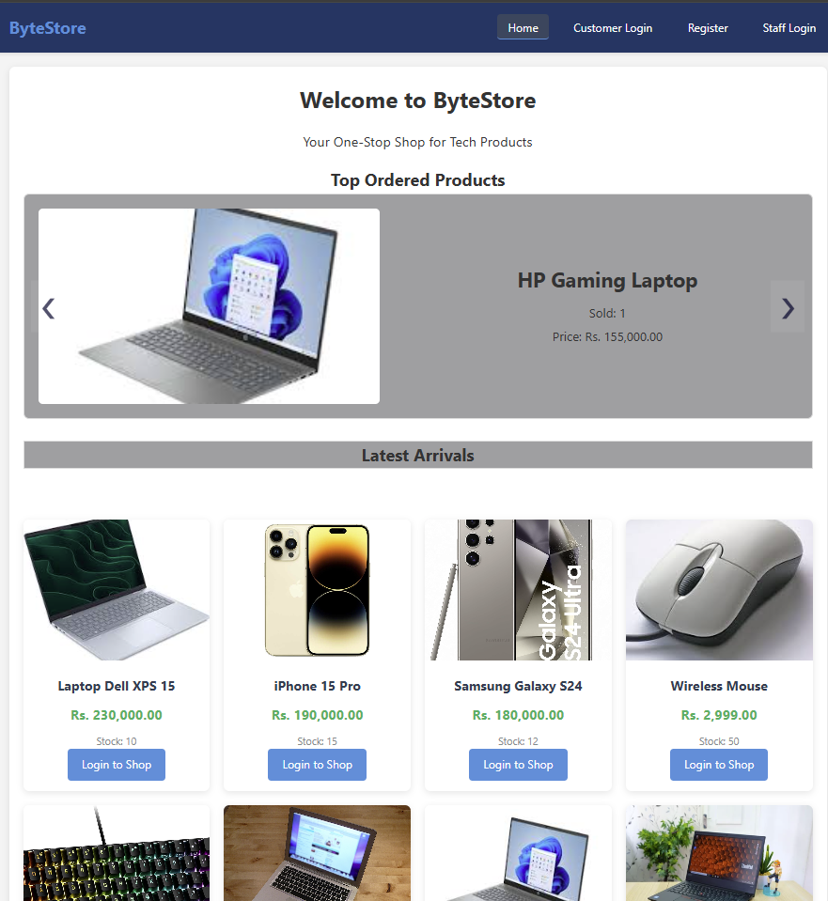

Figure 13:Home Page demonstration of Bytestore

Different modules of this system are described as below:
Login Module
In login module, ByteStore involves a secure and user-friendly authentication process to ensure access control. Both users and employees’ providers typically have distinct login interfaces. For users, the login page captures unique identifiers such as username or email and password. Additional security measures like two-factor authentication may enhance protection. Retail providers log in with professional credentials, including a unique identifier and password. The system verifies these credentials against stored records in the database. Upon successful login, users gain access to personalized dashboards, allowing users to schedule orders and view retail information, while employees can manage orders and view user details.
Register Module
In register module, we have implemented two sub modules, they are user register and Employee register. User and Employee register into the system by entering all the details such as first name, last name username and password required to register. And then can log in to the system with their valid username and password.

Testing
For the application or website to be deployed it must be tested. Hence test cases will be written to test this application. There are many types of tests to be carried out on a web application from performance, functionality, database loading time, response time, server time handling, user's actions, and many others. I will not carry out all types of tests for the application considering the time scale to present this project. Hence performance check related to upload time, memory usage will be part of a future test. I will focus the test cases on functionality, security and performance.
The later test on the website will make sure that the website provides the right results and outcome. The test will help reduce unpredictability on the website. I will run tests on various browsers making sure that the application produces the same result and is stable on the major popular browsers.

Test Cases for Unit Testing

Table 2:Unit Testing of Bytestore
S.N. | Test Name | Input | Expected Outcome | Actual Output | Result
1 | Customer Registration (Valid) | Full Name: abc xyz  Email:test@example.com  Password:Abc12345!  Address: Nepal | Registration successful | Registration successful | Pass
`2 | Customer Registration (Empty Fields) | Full Name: (blank)  Email: test@example.com  Password: Abc12345!  Address: Nepal | Error message shown | Registration allowed | Fail
3 | Customer Registration (Invalid Email) | Full Name: abc xyz  Email: test.com  Password: Abc12345!  Address: Nepal | Invalid email error | Error message shown | Pass
4 | Customer Registration (Weak Password) | Full Name: abc xyz  Email: test2@example.com  Password: abc123Address: Nepal | Password validation error | Error message shown | Pass
5 | Login (Valid Credentials) | Email: test@example.com  Password: Abc12345! | Redirect to home page | Redirected to home page | Pass
6 | Login (Invalid Password) | Email:test@example.com  Password: wrongpass | Login failed message | Error shown | Pass
7 | Login (Unregistered Email) | Email:unknown@example.com  Password: Abc12345! | User not found error | Login page reloads | Fail
8 | Add to Cart (Valid) | Item selected  Quantity: 1 | Item added to cart | Item added | Pass
9 | Add to Cart (Zero Quantity) | Item selected  Quantity: 0 | Item not added | Item added | Fail
10 | Update Cart Quantity | Quantity changed to 3 | Cart updated | Quantity updated | Pass
11 | Remove Item from Cart | Remove button clicked | Item removed | Item removed | Pass
12 | Checkout (Valid) | Cart items present  Valid address | Order placed successfully | Order confirmed | Pass
13 | Checkout (Empty Cart) | No items in cart | Checkout blocked | Checkout allowed | Fail
14 | Logout | Logout clicked | User logged out | Redirected to login page | Pass

Test Cases for System Testing

Table 3:System Testing of Bytestore
S.N. | Scenario | Expected Result | Actual Result | Result
1 | Full Purchase Flow | Order placed, stock reduced | Success | Pass
2 | Employee Add Product | Product in DB | Added | Pass
3 | Search Product | Matching results | Displayed | Pass

: Conclusion and Future Recommendations

Lesson Learnt / Outcome
The development of ByteStore has resulted in a fully functional, web-based e-commerce platform dedicated to the buying and selling of technology products such as laptops, peripherals, accessories, and electronic devices. Upon project completion, users can browse available products through a structured catalog system, search for desired items using filters such as name, category, or price, and view detailed product descriptions and images before making a purchase decision. Registered users can conveniently add products to the shopping cart, proceed with checkout, and place orders through an intuitive and user-friendly interface.
From the development perspective, the project provided valuable practical exposure to real-world web application development. It strengthened understanding of PHP, MySQL, JavaScript, HTML, CSS, and overall system integration in a real operational environment. Implementing authentication, maintaining session handling, ensuring data flow integrity, and managing databases helped in gaining deeper knowledge of backend logic and secure transaction handling. The process also emphasized the importance of structured system analysis, database design, requirements prioritization, and modular development.
Overall, the project enhanced both technical competency and problem-solving skills, proving to be academically enriching as well as practically insightful.

Conclusion
The primary objective of ByteStore was to design and develop a complete, reliable, and efficient online platform where users can conveniently explore and purchase technological products through a structured digital environment. The system successfully fulfills these objectives by providing key features such as user registration and login, browsing and searching products, maintaining a shopping cart, order placement, and structured administrative control. Throughout development, the project strictly adhered to system requirements while also introducing necessary enhancements to improve usability and performance.
The journey of building ByteStore was highly educational and challenging. The project demanded careful planning in selecting the appropriate architecture, designing the database structure, ensuring smooth interaction between system modules, and maintaining logical accuracy throughout the platform. Backend implementation, database connectivity, and ensuring consistency of system responses required rigorous effort and testing. However, with systematic development and continuous refinement, these challenges were addressed successfully.
PHP was chosen for development due to its simplicity, reliability, wide community support, and strong integration capability with MySQL. Combined with HTML, CSS, JavaScript, and XAMPP server environment, it enabled efficient development of a dynamic and platform-independent system.
With the successful completion of this project, ByteStore now stands as a functional foundation for a scalable and feature-rich e-commerce platform. While the existing system effectively meets core objectives, there remains significant potential for future enhancements to make it even more robust and commercially viable.

Future Recommendations
Although ByteStore is fully functional, several improvements can further enhance its usability, scalability, and commercial readiness in the future. The following recommendations are proposed for further development:
• Integration of secure online payment gateways for real-time transactions
• Implementation of advanced product categorization and filtering
• Addition of an enhanced order management and tracking system
• Development of a modern and customizable user interface theme system
• Introduction of warranty, return, and refund management features
• Customer review and rating system for products
• Development of a mobile application version for better accessibility
• Real-time stock management and low-stock alerts
• Wishlist functionality for users
• Admin dashboard analytics with sales insights and reports
• Improved user experience and performance optimization

References
[1] | O. A. Oluwatope, "Development and Implementation of E-Commerce System," International Journal of Computer Applications, vol. 179, p. 24, Feb. 2018.
[2] | Olist, "Brazilian E-Commerce Public Dataset by Olist,Kaggle," 2018. [Online]. Available: https://www.kaggle.com/datasets/olistbr/brazilian-ecommerce.
[3] | SourceCodester, "E-Commerce System Using PHP/MySQLi with Source Code," 2020.. [Online]. Available: https://www.sourcecodester.com/php/13524/e-commerce-system-using-phpmysqli.html..
[4] | DevendraChapagain, "researchgate," October 2024. [Online]. Available: https://www.researchgate.net/publication/385110843_E-commerce_in_Nepal_Growth_Opportunities_and_Threats.
[5] | Pathak_Chiranjivi., "theseus," 2020. [Online]. Available: https://www.theseus.fi/bitstream/handle/10024/353802/Pathak_Chiranjivi.pdf.
[6] | Arjan, "gurkhatech," 25 August 2025. [Online]. Available: https://gurkhatech.com/nepal-ecommerce-digital-marketing-research.
[7] | HarisankerPandey, "ijraset," 26 05 2023. [Online]. Available: https://www.ijraset.com/research-paper/development-of-e-commerce-website.
[8] | S. A. Vipin Jain, "Journal of Contemporary Issues in Business and Government," An Overview of Electronic Commerce, p. 670, May 2021.
[9] | AhmedYahyaE, "github," [Online]. Available: https://github.com/AhmedYahyaE/plain-php-ecommerce.
[10] | CampCodes Administrator, "campcodes," [Online]. Available: https://www.campcodes.com/projects/e-commerce-system-in-php-mysql/?utm.
[11] | Kristina, "E- Commerce Website," https://www.scribd.com/document/866451594/Final-Report?utm, September 18, 2024.
[12] | Ujjwal, ""DOCTOR APPOINTMENT SYSTEM"".
[13] | Bishal, "Online Vehicle Renting," 2025.
[14] | P. Costa, "The ever-changing business of e-commerce-net benefits while designing a new platform for small companies," 28 October 2022. [Online]. Available: https://link.springer.com/article/10.1007/s11846-023-00681-6?utm.
[15] | K. Ganesh, ""DOCTOR APPOINTMENT SYSTEM"," 2025.
[16] | M. Rashmita, "Online Vehicle Renting," 2025.
[17] | S. Anusha, ""EasyBookings't," 2025.
[18] | SiddiquiMuhammadasir, "arxiv," 19 Jun 2024. [Online]. Available: https://arxiv.org/abs/2406.15498.

Appendix

Home Page
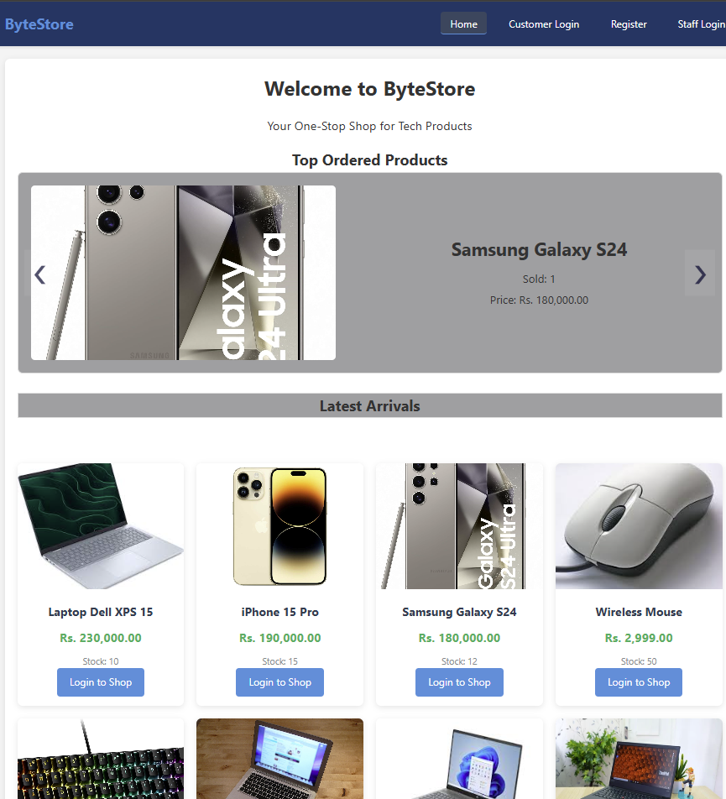

Figure 14:Home Page of Bytestore

Customer Login
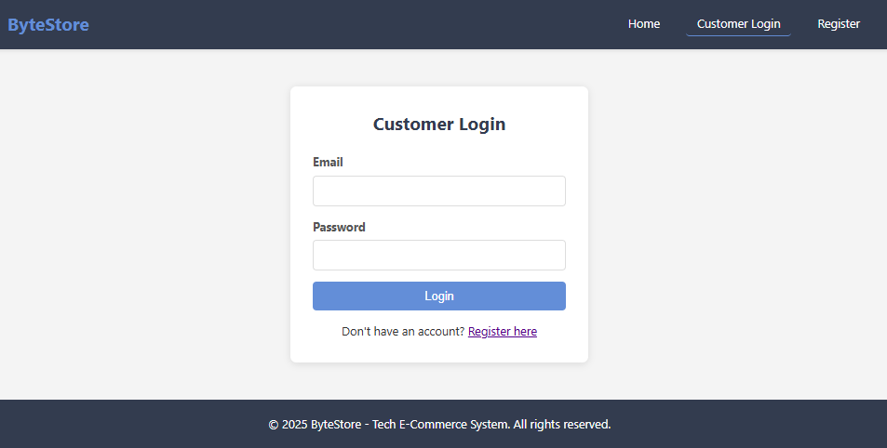

Figure 15:Customer Login of Bytestore

Customer Registration
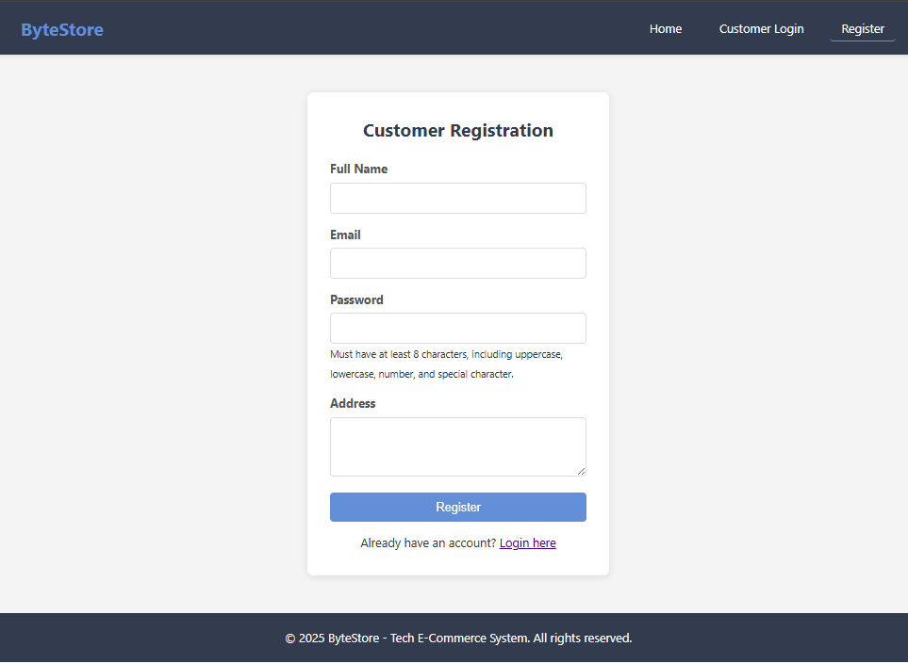

Figure 16: Customer Registration of Bytestore

Registered user homepage

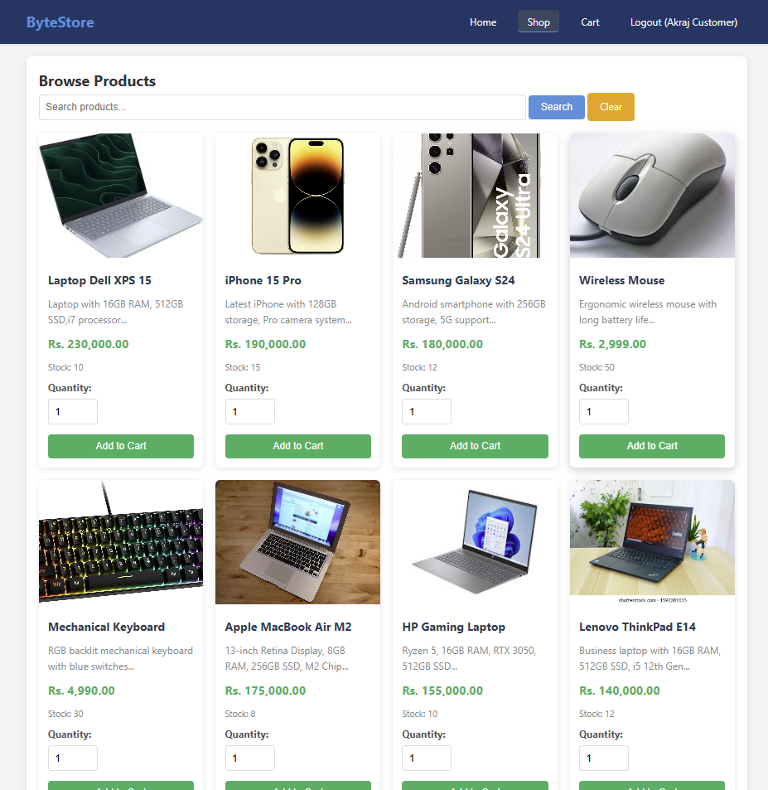

Figure 17:Registered user homepage of Bytestore

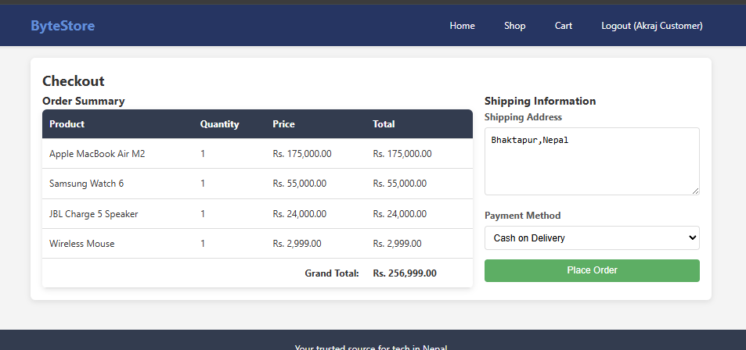

Figure 18:Checkout Page of Bytestore
Staff Login
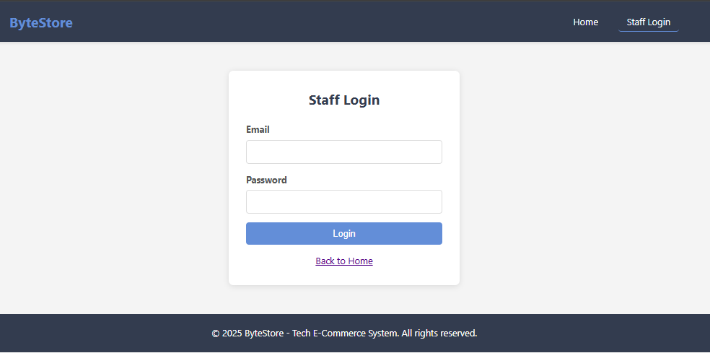

Figure 19: Staff Login of Bytestore
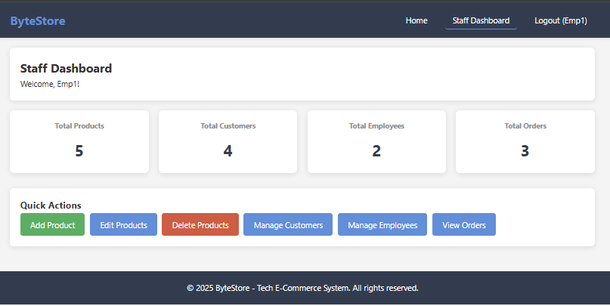

Figure 20:Staff(Employee) dashboard of Bytestore

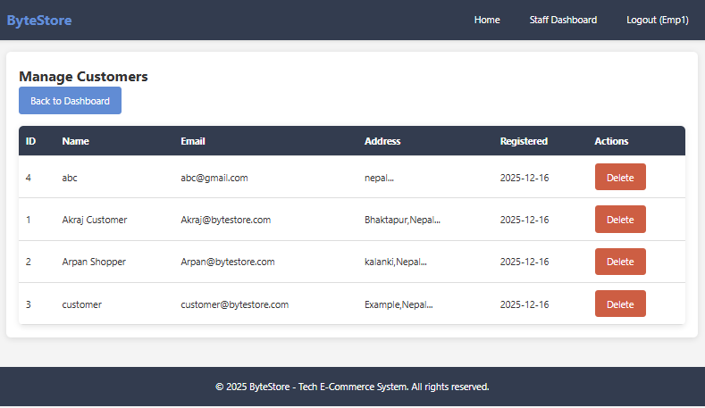

Figure 21:Customer Management of Bytestore
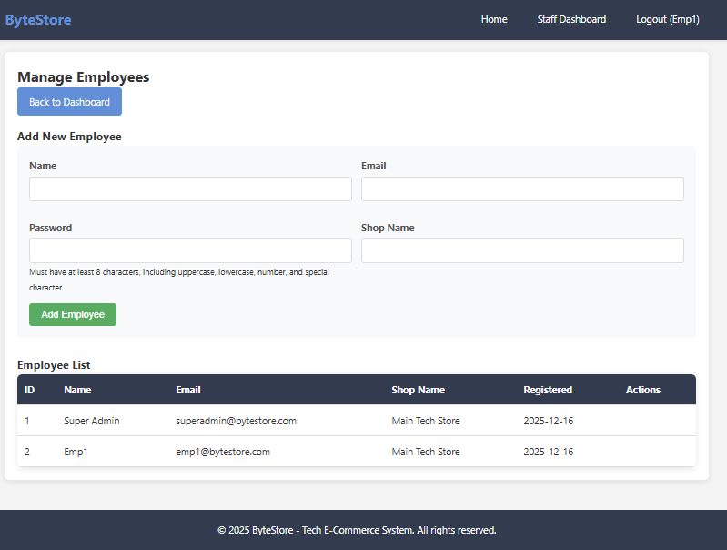

Figure 22:Employee Management of Bytestore

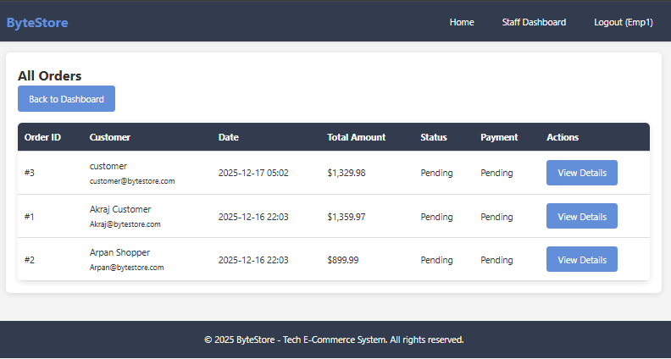

Figure:23Orders Tab of Bytestore
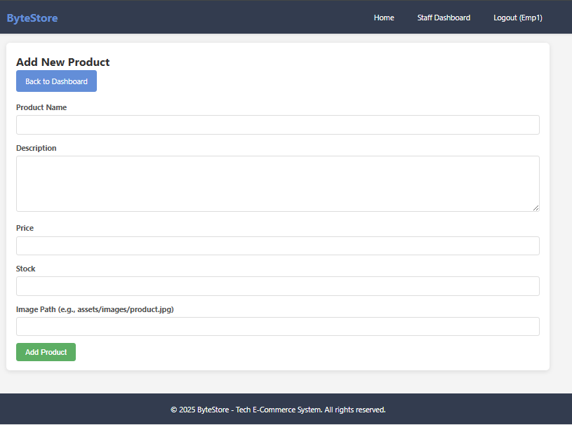

Figure 24:Add New Order of Bytestore

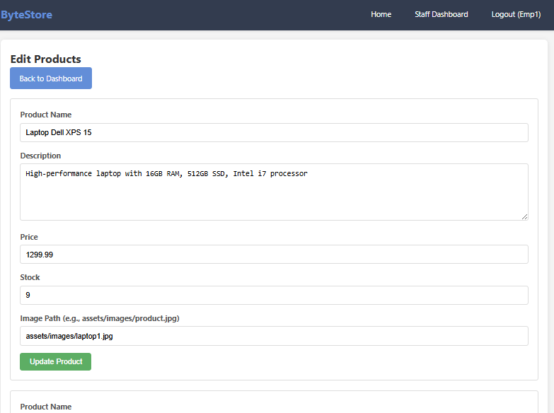

Figure 25:Editing Products of Bytestore
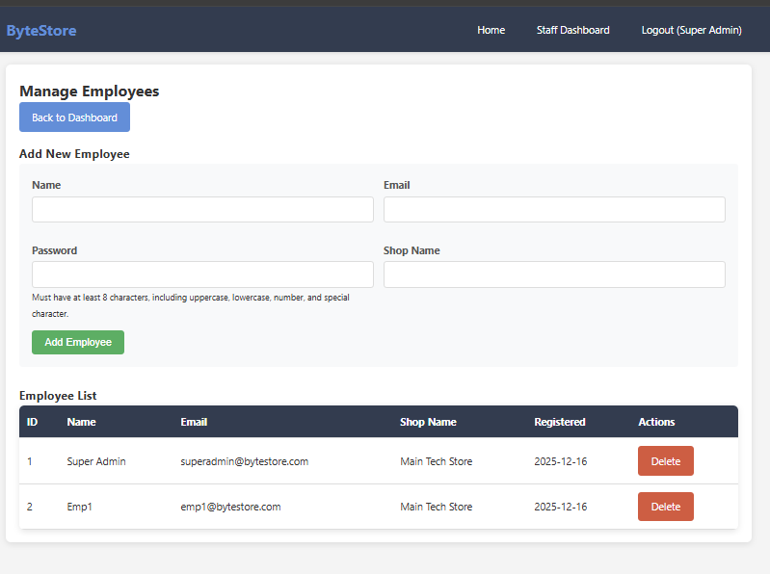

Figure 26:Management of Employee by Admin of Bytestore

